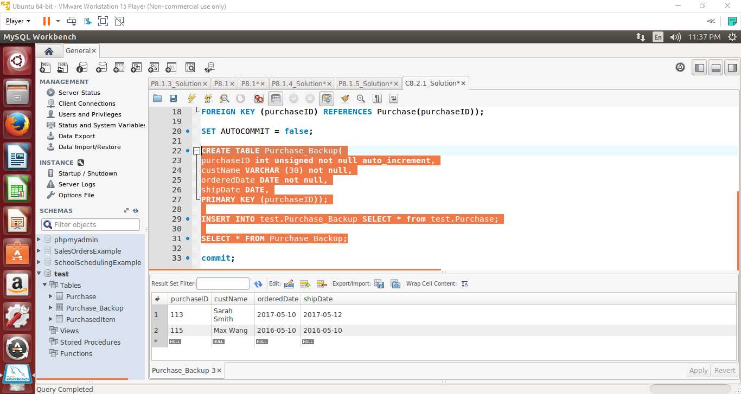

First, I created a new table in the same database called Purchase_Backup. This database had the same exact structure as the Purchase table.

Then I executed INSERT INTO test.Purchase_Backup SELECT * from test.Purchase;

The first part of the INSERT INTO statement is to define the destination of where everything will be copied to. The last portion defines the source table it will copy from. You may have notice that the source and destination tables have “test.” before the table name. “test” is the name of the database, meaning that it is possible to copy a table from one database to another.